**ASSET 4:-** Deleting all empty gcp buckets.

**Problem:-** Leaving empty buckets will just make over head to maintain.

**Solution:-** Python script to delete all empty buckets using cloud function and cloud scheduler.

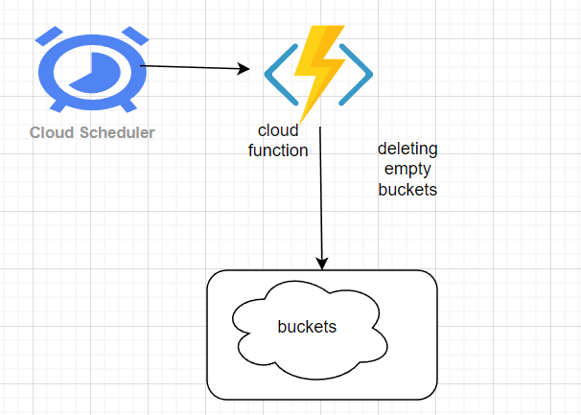

**Flow:-**

From cloud scheduler a job will trigger a cloud function through http url and executes python script to delete all the empty buckets.

**Steps involved:**

Infrastructure creation using terraform.

**Resources: -**

1. Cloud scheduler
2. Cloud function

**Folder structure:-**

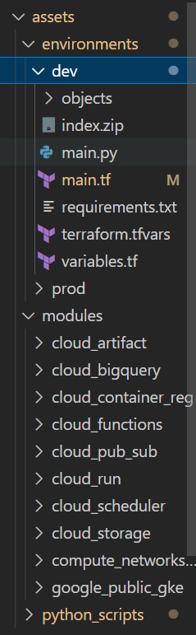

**Infra code for cloud scheduler:**

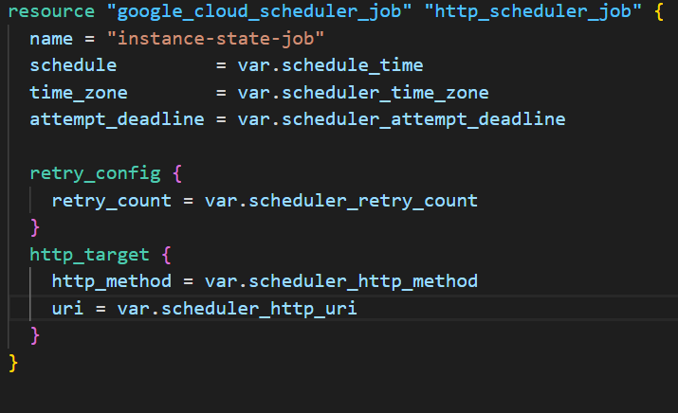

**Infra code for cloud function:**

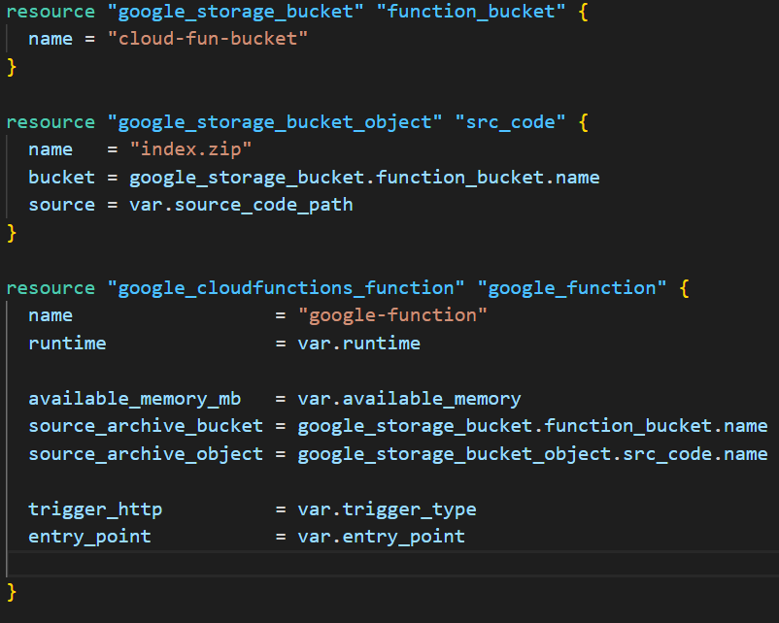

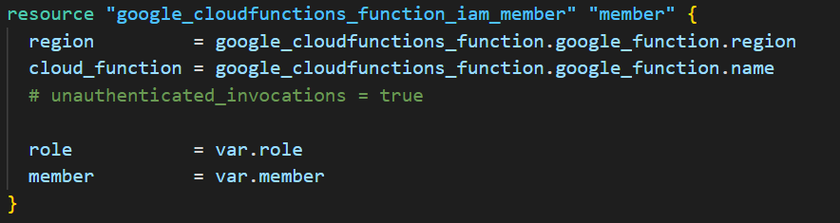

This below code is from modules from here we will have to pass the values to the main.tf file.

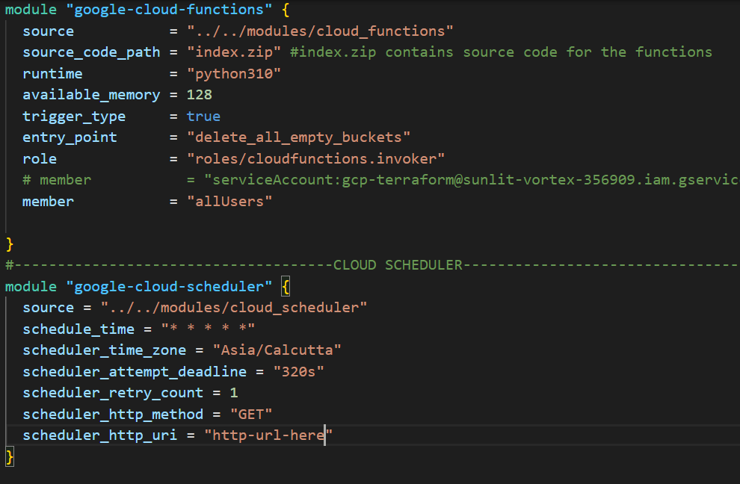

**Python script for all empty buckets--**

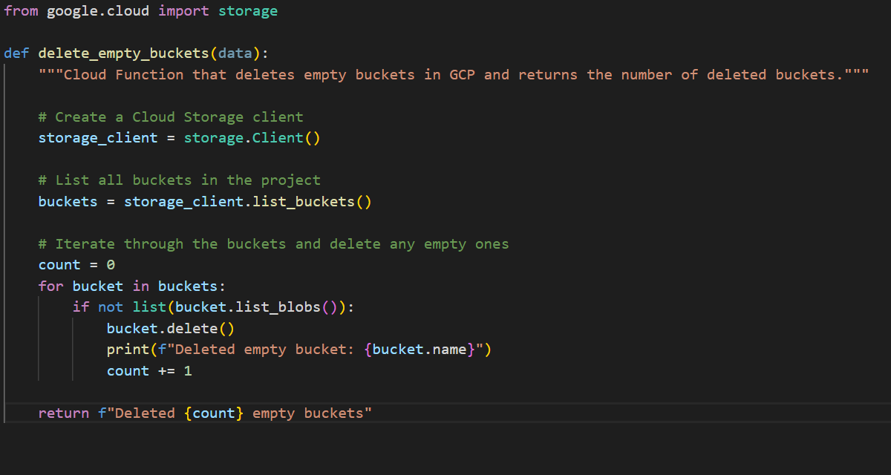

**Output:-**

**For no empty** buckets

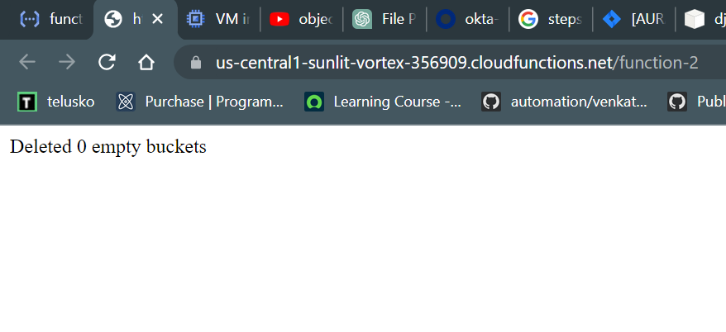

For empty buckets deletion:

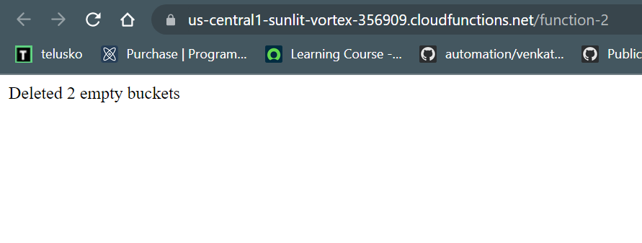

**Store logs of the output**

**Other small assets:**

[**https://github.dxc.com/vbukka3/devops-mentorship-scripts**](https://github.dxc.com/vbukka3/devops-mentorship-scripts)